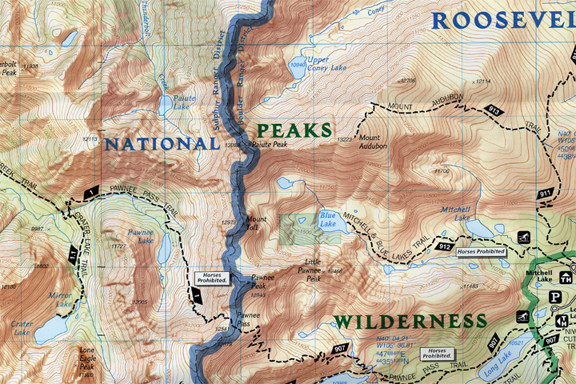
Day One

Pawnee Pass Trail (7.7 mi)
Elevation Range: 10,040-12,541
Moderate – Difficult
Crater Lake Trail (1.2 mi)
Elevation Range: 10,040-10,350
Moderate
Cascade Creek Trail (2.5 mi)
Elevation Range: 8,340-10,040
Moderate

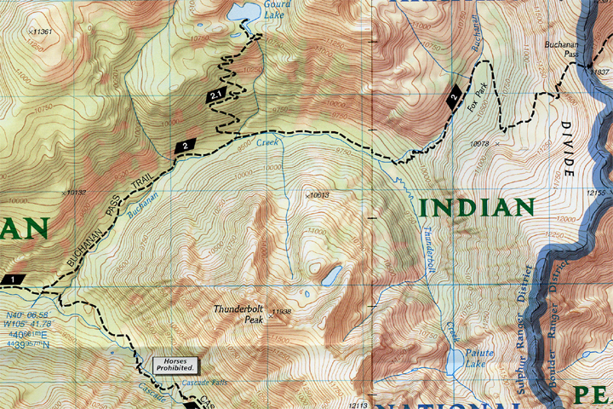
Day Two

Cascade Creek Trail (2.5 mi)
Elevation Range: 8,340-10,040
Moderate
Gourd Lake Trail (2.7 mi)
Elevation Range: 9,538-10,838
Moderate
Buchanan Pass Trail (6 mi)
Elevation Range: 8,565-11,840
Moderate

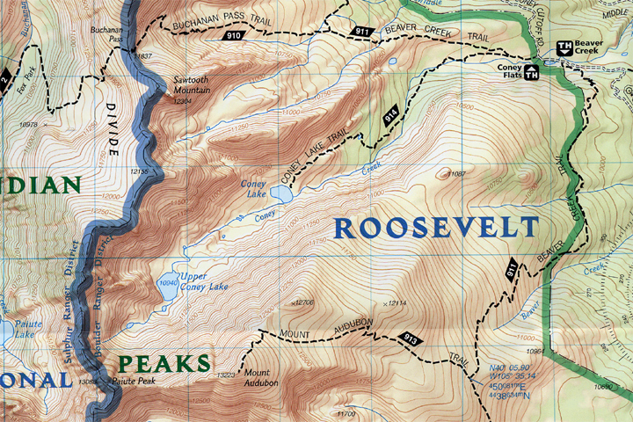
Day Three

Buchanan Pass Trail (3 mi)
Elevation Range: 8,565-11,840
Moderate
Coney Lake Trail (2.3 mi)
Elevation Range: 9,840-10,699
Moderate
Beaver Creek Trail (6.6 mi)
Elevation Range: 9,789-11,376
Moderate

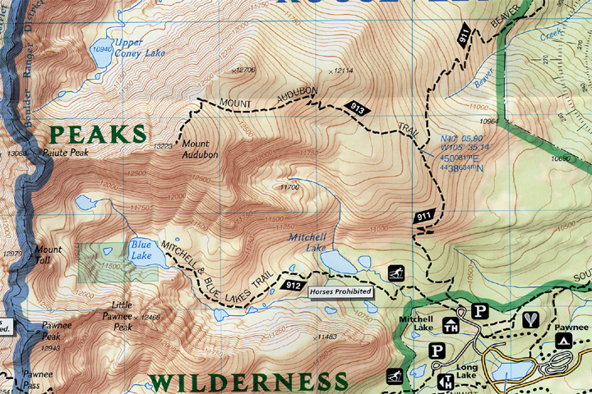
Day Four

Beaver Creek Trail (6.6 mi)
Elevation Range: 9,789-11,376
Moderate
Mount Audubon Trail (2.2 mi)
Elevation Range: 11,375-13,223
Moderate

